Name : | Mrunali Jibhakate | Class/roll no : | 6th EE B - 107
Reg. No : | 23071350
Aim : | To demonstrate and implement data grouping, aggregation functions, and horizontal concatenation of multiple datasets using the Python pandas library.,
Implementation Steps : | Part A: Grouping and Aggregation  - Data Definition:  - Grouping  - Aggregation.  Part B: Dataframe Concatenation  - Multiple Data Sources  - Horizontal Stacking
Program Code : | - import numpy as np # linear algebra  import pandas as pd # data processing, CSV file I/O (e.g. pd.read_csv)  # Input data files are available in the read-only "../input/" directory  # For example, running this (by clicking run or pressing Shift+Enter) will list all files under the input directory  import os  for dirname, _, filenames in os.walk('/kaggle/input'):  for filename in filenames:  print(os.path.join(dirname, filename  - data1 = {'Name': ['Jai', 'Anuj', 'Jai', 'Princi',  'Gaurav', 'Anuj', 'Princi', 'Abhi'],  'Age': [27, 24, 22, 32,  33, 36, 27, 32]  'Address': ['Nagpur', 'Kanpur', 'Allahabad', 'Kannuaj',  'Jaunpur', 'Kanpur', 'Allahabad', 'Aligarh'],  'Qualification': ['Msc', 'MA', 'MCA', 'Phd',  'B.Tech', 'B.com', 'Msc', 'MA']}  - df = pd.DataFrame(data1)  grp1 = df.groupby('Name')  grp1.aggregate(np.sum)  - # Define a dictionary containing employee data  data1 = {'key': ['K0', 'K1', 'K2', 'K3'],  'Name':['Jai', 'Princi', 'Gaurav', 'Anuj'],  'Age':[27, 24, 22, 32]}  # Define a dictionary containing employee data  data2 = {'key': ['K0', 'K1', 'K2', 'K3'],  'Address':['Nagpur', 'Kanpur', 'Allahabad', 'Kannuaj'],  'Qualification':['Btech', 'B.A', 'Bcom', 'B.hons']}  # Convert the dictionary into DataFrame  df = pd.DataFrame(data1)  # Convert the dictionary into DataFrame  df1 = pd.DataFrame(data2)  display(df, df1)  - res = pd.concat([df, df1], axis=1)  res
Output : | 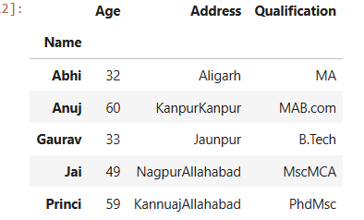  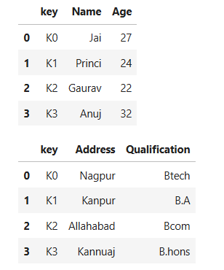  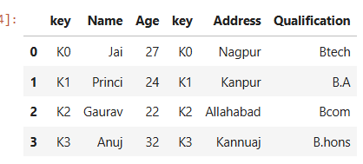
Result : | This lab successfully demonstrates how to consolidate data. Grouping is essential for summarizing large datasets based on categories, while Concatenation allows for the integration of data from different sources into a unified structure.

Marks : |  | Name of Lecturer : Dr. S.A. Dhondse
 |  | Signature :

